D’var Torah Lech Lecha
HIAS National Refugee Shabbat 10/21/18

Shabbat Shalom. I’m Michael Schaal. Rabbi Amy asked me to give the D’var Torah, in her absence.

Today, along with many other Jewish people, we observe the HIAS National Refugee Day. HIAS was originally founded as the Hebrew Immigrant Aid Society. Some of you either directly or indirectly are here because of the work of HIAS in your family immigration story.
The following is a quote from the HIAS web site regarding the intention of this observance.
“National Refugee Shabbat 2018 is a moment for congregations, organizations, and individuals around the country to create a Shabbat experience dedicated to refugees.
This national event is a meaningful opportunity to deepen our understanding of today’s global refugee crisis, connect with the Jewish movement for refugees, commit (or recommit) to taking action, and either celebrate your community’s achievements in working with refugees or launch new efforts…
According to (the) annual Global Trends report, of UNHCR, the UN Refugee Agency,
There are now 68.5 million displaced persons world wide. 25.4 million are refugees. Of those 3.1 million are asylum seekers. The numbers of displaced persons are the highest in history. Someone is displaced from their home approximately every 2 seconds. An average of 44,000 individuals per day leave their homes to seek protection elsewhere.
End Quote
We read in a earlier part of this Shabbat Parsha, Quoting from the text “The Lord said to Abram Go forth from your native land and your father’s house to the land that I will show you”…End quote.

The Lord promises to make Abram (he was not yet Abraham), a great nation. Abram leaves with his wife Sarai (who is not yet Sarah) and with his brother’s son Lot. They go to the land of Canaan, where the Lord has led them. Abram is told that the land will be assigned to his offspring.
But then, we are told that when they are in the land that they have been led to, there is famine and they leave again, this time for Egypt.

Abram and Sarai are refugees in Egypt and they worry about how they will survive. They hatch a plan to tell this Pharaoh (not the Pharaoh of Moses) and the Egyptians that they are brother and sister, not husband and wife. Abram fears that because Sarai is beautiful, that Pharaoh will want Sarai for himself. He will have Abram killed if he knows that they are they are husband and wife. Elsewhere in Torah during their travels they hatch a similar plot and tell the same stories in order to save Abram’s life.

Abram, who will become Abraham, and eventually argue with G-d about the justice of destroying Sodom and Gemorah, is willing to use guile and cunning to survive starvation in the land of Egypt, to save his life. They are found out by Pharaoh, but spared, and indeed they thrive. Was it illegal to lie to Pharaoh? Probably. Abram and Sarai leave Egypt wealthy and return to the land that they have been promised.
Later when Abraham argues with G-d he does so when he is wealthy, not poor and when he has enough to eat and does not fear dying of starvation.

Emigration: to leave what you do know and go to what you do not know, in some cases to risk everything in order to survive. To hope, in the face of what is sometimes utter despair.
Perhaps you are young and ready for an adventure. Perhaps you do have ill and illegal intent and plan to exploit a country through which you travel or a country that is your destination. Among those who emigrate from a place and immigrate to another country, there is always a minority who wish to traffic, smuggle or spy. But they are a distinct minority.

Of the 68.5 million displaced persons world wide, the vast majority are in their status because of war and other forms of suffering. Most have been on the move because they were forced to leave, or found the conditions of their environment so onerous that leaving was the only option, sometimes, the only alternative to death. Many have left family members behind, some of whom will never be seen again.

As we know, for those traveling to this country with children, driven to leave by great danger, they run the risk of separation from their children, and trauma for all members of the family that can last a lifetime.

Desperation can lead to behavior that is exceptional, sometimes illegal. It is bogus to conflate illegal actions that are rooted in trying to survive with those that are intended to exploit for personal power or profit.

June 26 1940
Memo from Samuel Breckinridge Long,
Assistant Secretary of State, United States of America
Supervisor Visa Division overseeing American Immigration and Transit
Visas at Overseas Consulates.

Quote Excerpts from a memo sent by Long to colleagues in the State Department outlining a strategy of blocking the immigration of those escaping from Europe, many of them Jews before and during the Holocaust.

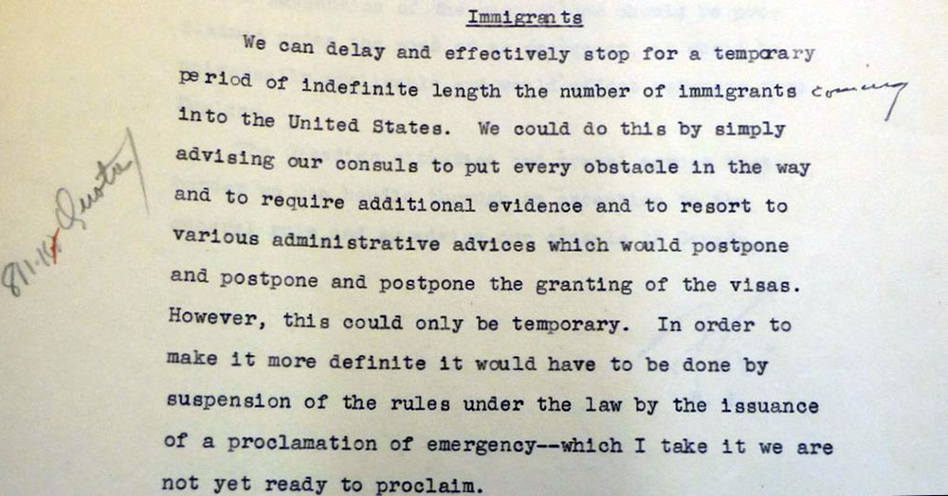
End Quote

Some of you have heard me speak from this Bima before, of my great grandmother Clementine Urbach, who died a few years before I was born .
As a result of the American consulate in Berlin “losing her Immigration papers” to the United States, she was ordered to come to the collection point in Berlin sometime in 1942 or 1943. She was last seen by a family friend in the infirmary at Theresinstadt about a month later. The next morning she was shipped to Treblinka where we believe she was gassed on arrival.

By the time that she left Berlin, her family, her daughters, their husbands and her grandchildren had all been able to escape, and were scattered in different countries, England, Switzerland, then Palestine (later to become Israel) and the United States.

If by some miracle someone would have said to my great-grandmother,
“Clem, you know that Jews who leave on those trains, don’t come back. We think that we can save you, get you out, but there is one thing that you should know. It would be illegal”.
If somehow that could have happened, I know what all of our family would have wanted her to do. She never had the chance to take illegal actions that might have saved her life.From the United States Holocaust Museum. Quote

RESCUE RESOLUTION

In November 1942, American newspapers and magazines printed announcements about the Nazi regime’s plan to murder European Jews. Some Americans wrote passionate letters and telegrams to the State Department expressing their concern and pleading for rescue action. Others held public rallies calling on the US government to rescue or provide relief for the Nazis’ victims.
(Breckinridge) Long contended that rescue was impossible without harming the Allied war effort, and he tried to calm criticism by making it look like the government was doing more than it really was. In April 1943, delegates from the United States and Great Britain met for the Bermuda Conference, but Long gave the Americans strict instructions ensuring that the negotiations would not lead to any significant new steps on behalf of Europe’s Jews. Long also briefly attempted to stop reports of mass murder from reaching the United States because he feared that releasing the news might lead to additional pressure on the State Department.”

…In January 1944, US Treasury Department officials discovered Long’s efforts to suppress information about the Holocaust. These officials successfully petitioned Roosevelt to create the War Refugee Board and announce a new US policy of relief and rescue for Jews and other victims of Nazism. Approximately five million Jewish victims of the Nazi regime had already been murdered at this point. Long was removed from supervision of the Visa Division, and eleven months later, he resigned from the State Department.
Quoting again from the HIAS Web Site:
(Since the passage of the Refugee Act of 1980 the),
Maximum number of refugees resettled in the U.S. in any given year, is referred to as the ceiling for refugee admissions. This ceiling (which) is set annually, is known as the Presidential Determination.
For more than a decade the annual ceiling was 70,000 which included refugees from all countries. Former President Obama raised the ceiling to 85,000 in 2016, and then 110,00 for 2017.
The Executive Order issued by the Trump Administration on March 6, 2017 dropped this number to 50,000. For 2018 the Presidential Determination is that the number will be 45,000. As of September 17, the actual number resettled has been 20,918 , less than half of the 45,000 ceiling. For 2019 the ceiling number announced had dropped to 30,000. That is the lowest number set by any Presidential determination since the Refugee Act became law in 1980. End quote.
Paraphrasing from the HIAS website.
- …In April 2018, the administration announced implementation of a zero-tolerance policy. This policy meant that individuals apprehended crossing the border, not at a port-of-entry would be criminally prosecuted, which led to not only criminal prosecution but also detention and then the separation of families.
…A judge ruled that all children that were separated from their families due to the zero-tolerance
policy had to be reunited…
. The government failed to meet (this ruling). As of this moment
children remain separated from their families. Almost five hundred parents were deported and are not in the same country as their children.
Asylum seekers are being forced to wait, frequently for days, on the Mexican side of the border, sometimes being told that ports-of-entry are full, and sometimes being told that the U.S. is no longer accepting asylum applications.
 
Among new proposals being considered by the Trump Administration regarding asylum (are the following):
Individuals apprehended at the border for not entering at a port-of-entry, will no longer be eligible for asylum.
Gang violence and domestic violence perpetrated on seekers of asylum would not qualify individuals for asylum.
Anyone who had traveled more than 2 weeks, or passed through more than 1 country to get to the U.S., will not be eligible for asylum.
Reference to Mexico Safe Third Country Agreement
End of references to the HIAS web site.

An Immigration and Sanctuary Group has been meeting at Ohavi Zedek roughly every two weeks, Sundays at 6:00 P.M. to consider action steps that we might take as individuals and as a Jewish Community.
No one will be pressured to do anything that they do not wish to do. The goal is to gather pertinent information and develop thoughtful and meaningful actions that we can take as individuals and as a group to impact these issues
There will be a meeting tomorrow evening in the Small Sanctuary. There is information that will be available in the Social Hall for those who wish to know how to participate or to be part of an email list in order to keep informed.
After we share in the Nachas of this day with those who are co-sponsoring the Kiddush, members of our Group will facilitate a discussion during lunch about refugees and Immigration.
The refugee crisis that we on the planet face now is not a new story. It is a moral crisis that we as Jews have lived since before the existence of Torah. The story has touched our people and others in deeply personal ways, including some of us who are in this sanctuary today.
At a moment in time when Journalists can be cut to pieces, and when claims of illegality can be used to justify all manner of persecution, we as a Congregation, and as a people, cannot allow ourselves to be unconscious, muted and idle while there is suffering that we can prevent or positively impact. We also cannot overlook interconnections between the problems of Refugees and other factors like the escalation of the deteriorating environment, and the increasing gap in Income inequality.
We owe it to this baby that we have welcomed today and to the children of her generation. We owe it to those who are displaced persons and refugees around the world, those who are in similar circumstances to the ones that we have faced as a people, not so long ago. We owe all of them hope and a vision of possibility We owe that to ourselves as a moral and religious Jewish Community.
. Shabbat Shalom.

