`
BLESSING FOR BAR MITZVAH
May you live to see your world fulfilled,
may you be our link to future worlds,
and may your hope encompass
all the generations yet to be.
May your heart conceive with understanding,
may your mouth speak wisdom,
and your tongue be stirred with sounds of joy.
May your gaze be straight and sure,
your eyes be lit with Torah's lamp,
your face aglow with heaven's radiance,
your lips expressing words of knowledge,
and your inner self alive with righteousness.
And may you always rush in eagerness to hear
The words of One more ancient than all time.

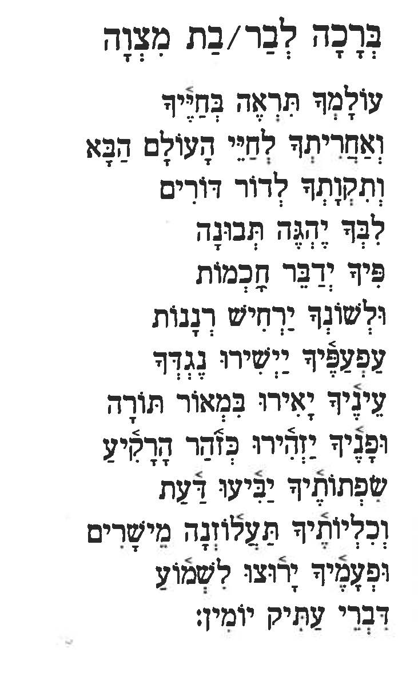

Welcome to the
B Mitzvah
Of
Child’s Name

We are delighted and honored you have come to share this joyous occasion of Child’s Name {B, Bar or BAT} Mitzvah.

The act of becoming a Bar – Bat OR B Mitzvah – often translated as “son – daughter of the commandment(s)” – raises a Jewish child to the status of adult in the religious community. It marks the beginning of many obligations and privileges.

Perhaps a more appropriate definition would be “one who is prepared to take on the commandment(s),” because the B Mitzvah symbolizes the young person’s willingness to become responsible for the performance of Mitzvot – the duties of Jewish life.

Name’s B Mitzvah takes place during our Shabbat (Sabbath) service. During the service, we will hear portions chanted from the Torah. Torah means law and teaching, and is the handwritten parchment scroll of the Five Books of Moses. During each Shabbat and holiday, a prescribed portion of the Torah is read aloud in Hebrew. Today’s Torah portion is from the Book of name the book in the Torah here.

The Torah reading is divided into {three OR seven} sections. Each section is preceded and followed by blessings of thanks for the gift of Torah. The honor of being called to the bimah (pulpit) to say these blessings is called an Aliyah.

After the Torah reading, Name will share with us the meaning of this week’s reading and tell us about his/her/their Mitzvah project.

Today we bestow the honor of saying an aliyah, and other honors of participation in the service, upon the following family members:

First Aliyah NAME
Second Aliyah NAME
Third Aliyah NAME – {IF MINCHAH, THIS IS FOR THE B MITZVAH CHILD}
THESE ARE FOR MORNING SERVICES:
Fourth Aliyah NAME
Fifth Aliyah NAME
Sixth Aliyah NAME
Seventh Aliyah B MITZVAH CHILD
Lifting of Torah Scroll NAME

Dressing of Torah Scroll NAME

Carrying of Torah Scroll NAME

Closing of the Ark NAME

Thank you for coming and being part of this momentous day! We would like to thank Rabbi Amy, Cantor Steve, Naomi and the staff of Ohavi Zedek for making this day possible.

Shabbat Shalom,
PARENTS’ NAMES

