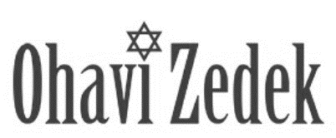

Honors and Torah Blessings - Shabbat Mincha B Mitzvah

B Mitzvah:

Date: Parashah:

Honor | English Name(s) | Hebrew Name(s) where applicable
Carry Scroll |  | -------------------------------
1st Aliyah

2nd Aliyah-PARENTS

3rd Aliyah (Bar/Bat Mitzvah)

Hagbah
(lifting of Torah scroll)
Gelilah
(dressing of Torah scroll)

Remarks from family members |  | -------------------------------
Closing ark at end of service |  | -------------------------------

Torah portion
Hebrew names (if applicable), NAME bat/ben PARENT & PARENT
Individual must be strong enough to lift the scroll over their head; at Rabbi’s discretion.
Closing Ark at end of service: 1-2 people. Doesn’t have to be Jewish.

