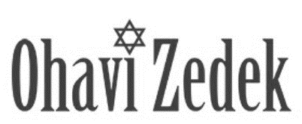

Honors and Torah Blessings – Shabbat Morning B Mitzvah

B Mitzvah: ___________________

Date: ______ Parashah: _______

Honor | English Name(s) | Hebrew Name(s) where applicable
Carry Small Scroll |  | -------------------------------
Kohen Aliyah

Levi Aliyah

Third Aliyah

Fourth Aliyah

Fifth Aliyah

Sixth Aliyah

Seventh Aliyah-PARENTS

Maftir (Bar/Bat Mitzvah)

Hagbah
(lifting of Torah scroll)
Gelilah
(dressing of Torah scroll)

Remarks from family members |  | NA
Closing ark at end of service |  | NA

Torah portion
Hebrew names, for those who are Jewish, NAME bat/ben FATHER &MOTHER
Optional for Jewish boy or girl under the age of Bar/Bat Mitzvah
Individual must be strong enough to lift the scroll over his/her head, at Rabbi’s discretion.
Closing Ark at end of service: 1-2 people. Doesn’t have to be Jewish.

