Welcome to ____’s B Mitzvah!

We are gathering for two reasons. In keeping with Jewish tradition, we will celebrate Shabbat. In Hebrew, Shabbat means Sabbath, or rest. Shabbat begins at sunset on Friday and continues for 25 hours until dark on Saturday evening. The Shabbat is considered a time of peace and reflection. And on this particular Shabbat, we are delighted that you will be with us as ____ becomes a [B, Bat or Bar] B Mitzvah.

This guide contains an explanation of the service and some aspects of Judaism and our synagogue. Thank you for sharing this very special moment with us!

(Looking for the event Zoom Link or prayer book? [Add link to prayer book - likely located in the OZ webpage Spiritual Life>Resources]

About B Mitzvah

Becoming a Bat, Bar or B Mitzvah is an important milestone in the lives of many Jews. It marks the passage of a child into young adulthood as a member of the Jewish community as they begin to take responsibility for their obligations (mitzvot) as a member of the Jewish people. It is the first time that _____ will read from the Torah (the first five books of the Hebrew Bible) and will share their own interpretations of it; a “Devar Torah.” ____ will wear a tallit, a prayer shawl with fringe corners, symbolically pointing to the value of 613, the number of commandments in Judaism.

____’s service takes place in just one afternoon, yet it celebrates much more: the affirmation of ____’s Jewish heritage, the work and learning that brought ____ to this moment and the important and unique person he/she/they is/are. It also invites us to contemplate ___’s and our collective futures.

____’s Mitzvah Project

Bat Mitzvah provides opportunities to study and learn; but also to take action. Judaism teaches that learning must lead to doing, and conduct is governed by “Mitzvot” (the plural of Mitzvah, meaning commandment or sacred obligation). Among the 613 mitzvot are those that direct our character and ethics, such as performing specific acts of kindness. This is an important and meaningful part of the preparation for becoming a B Mitzvah. ___ and his/her/their fellow students have each conducted a Mitzvah Project this year. Some undertook projects to improve the quality of life in their community, respond to the pandemic, help the environment or do some other act to improve our world. This is part of a tradition at Ohavi Zedek that provides the opportunity to enter into adulthood with the experience of living by mitzvot.

For ____’s project, … add specific details.

[Optionally, add photos of Mitzvah Project here]

B Mitzvah - The Name & Context

Bat Mitzvah means “Daughter of the Commandments” and Bar Mitzvah means “Son of the Commandments.” Bar Mitzvah is an ancient rite of passage for boys and the service celebrating bar mitzvah dates back to the middle ages. The first Bat Mitzvah -- for girls -- took place roughly 100 years ago, in 1922 in New York City. About 30 years later, at Ohavi Zedek, the first Bat Mitzvah was Miriam Gladstone Saiger in 1954. (OZ’s small sanctuary was dedicated by the Samuelson-Saiger family and is named the Samuelson/Saiger Chapel.) Bat Mitzvah became more common in the US around that time. Just as there is a tradition of men celebrating their second bar mitzvah 70 years after the first, today there is a tradition for women to celebrate a second Bat Mitzvah 70 years after their first - a very special occasion!

The term B’nai Mitzvah (Hebrew plural for Sons or mixed gender Children of Commandments) came into popular use for addressing either gender. Recently some Jewish organizations have explored updating this terminology and their practices to be more inclusive. In fact, today’s event marks the first in which Ohavi Zedek has begun to formally use the term “B Mitzvah” instead of “B’nai Mitzvah.” The name change, along with a variety of actions in development, reflect an aspiration to celebrate and welcome young adults of all gender identities and expressions.

Reinventing “Sanctuary” During The Pandemic

Normally, this service would be held in the synagogue’s sanctuary, in front of a holy Ark containing Torah scrolls. As we pivot during the pandemic, our family home will be transformed into a ‘temporary sanctuary.’ One of the synagogue’s Torahs will be brought to our home by the clergy during the week before the service. It will be wrapped in two large tallitot (prayer shawls) that act as a symbolic Ark. Rabbi Amy, Cantor Steve and ___ will each participate in the service from their own homes. We anticipate ___’s (vaccinated) grandparents will be at our home with us.

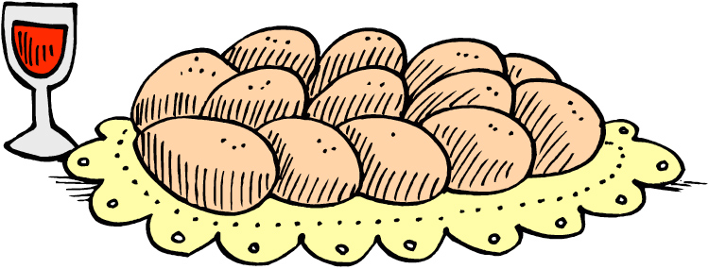

Shabbat Mincha (Afternoon) Service

___ will help Rabbi Amy and Cantor Steve lead the afternoon service, observing traditions and reciting/chanting prayers that have been a part of Shabbat services for many centuries. The traditional Shabbat service is divided into three sections:

- The Minchah (Afternoon Service)
Minchah includes both the Shema and the Amidah.

The Shema is the central affirmation of the Jewish faith, reminding Jews all over the world of the covenant with G-d.

The Amidah, or “standing prayer”’, is partially recited aloud and then the rest is recited privately by each of us. We will recite the first three blessings, Avot (parents, meaning our ancient ones), Gevurot, acknowledging G-d’s power, and then the Kedusha, a solemn prayer of sanctification.

Kaddish Shalem, the full kaddish, precedes the Torah service as a prayer of praise to G-d, so that all our prayers may ascend and be received.

- The Torah Service

The centerpiece of the Shabbat service is the reading of the Torah, a meticulously hand-scribed parchment scroll of the Five Books of Moses.

The begins as the b mitzvah student and others join the clergy on the Bimah. After introductory prayers, the Torah is removed from the Holy Ark/Aron Kodesh and the b mitzvah carries it through the sanctuary for worshippers to bless. The scroll is then opened for reading.

Special scribes hand-write each Torah. They use a distinctive script without vowels, punctuation or musical symbols in accordance with ancient practice. Stringent training is required to be able to read and chant from the Torah.

The Torah is divided into weekly portions; each called a parashah. On each Shabbat and holiday the same parashah/Torah portion is read the world over. This simultaneous reading creates a unique connection among Jews everywhere, and for us, elevates the B Mitzvah’s holiness.

____ will be reading is the portion called ________. These readings are found in the book of [add name of book], recounting [add brief summary of the parashah].

During our afternoon service, three sections (aliyot) will be read, each preceded and followed by blessings of thanks for the gift of the Torah. The act of being called up to recite the blessings is called an Aliyah, which means “going up”. It is considered a great honor to participate in any part of the Torah service.

Our Aliyah (Torah Blessing) Honorees are as follows:

- Name of first aliyah reader
- Name of second aliyah reader
- As the B Mitzvah, ____ is honored with the Maftir (final Aliyah).

When the Torah reading has been completed, the scroll will be rolled up and dressed in preparation for its return to the Ark.

- Concluding Prayers and Blessings (Additional Service)

After the Torah service, ____ will deliver a D’var Torah, his/her/their own interpretation of the Torah portion. There will be blessings by the Rabbi, parents and grandparents, including a reading(s) by _____.

The b mitzvah, Cantor Steve and Rabbi Amy will recite additional prayers.

At the conclusion of the service, friends and family may share a blessing and a mazal tov (well-wishes) to ____.

About Ohavi Zedek

Established in 1885, Ohavi Zedek Synagogue is Vermont’s oldest and largest Jewish Congregation. Ohavi Zedek means “Lovers of Justice.” It is home to Full Circle Preschool and OZ Hebrew School and Nadav Teen programs. OZ strives to be an inclusive house of prayer. Individual choice is an important value for Ohavi Zedek Synagogue, as is Tikkun Olam (the improvement of the World) and social justice.

Below is a summary of what can be found inside OZ’s sanctuary:

- The raised Hebrew lettering on the doors of our Ark is a symbolic representation of the Ten Commandments, which tradition teaches that Moses brought down from Mount Sinai.

- Suspended over the Ark is the Ner Tamid (eternal light). Its symbolic flame recalls the pillar of fire, which accompanied the Jews in their various travels on their way to Israel. An eternal light stood outside the Temple in Jerusalem, signifying the eternal nature of the Jewish covenant with God. You will find a Ner Tamid “burning” perpetually in every synagogue throughout the world.

- The platform from which the Torah is read is called the Bimah, meaning high place. According to tradition, we read the Torah from an elevated platform to signify our respect.

- Hanging mid way up the wall on the left side of the Bimah, is our Yad Vashem (translates to ‘memorial and name’), a memorial light commemorating the 6 million Jews who lost their lives during the Holocaust.

- The etched glass around the top of the Sanctuary represents the individual tribes of Israel, justice and the priestly benediction.

- The stained glass Tree of Life wall hangings to the left and to the right of the Ark represent Vermont and Jerusalem respectively.

- There are Menorahs with seven branches on either side of the sanctuary, the official symbol of the State of Israel. The Menorah is considered to be one of the oldest symbols of the Jewish faith.
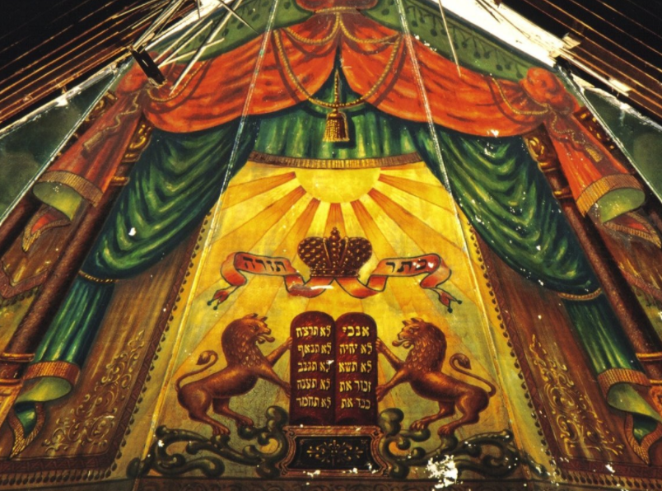
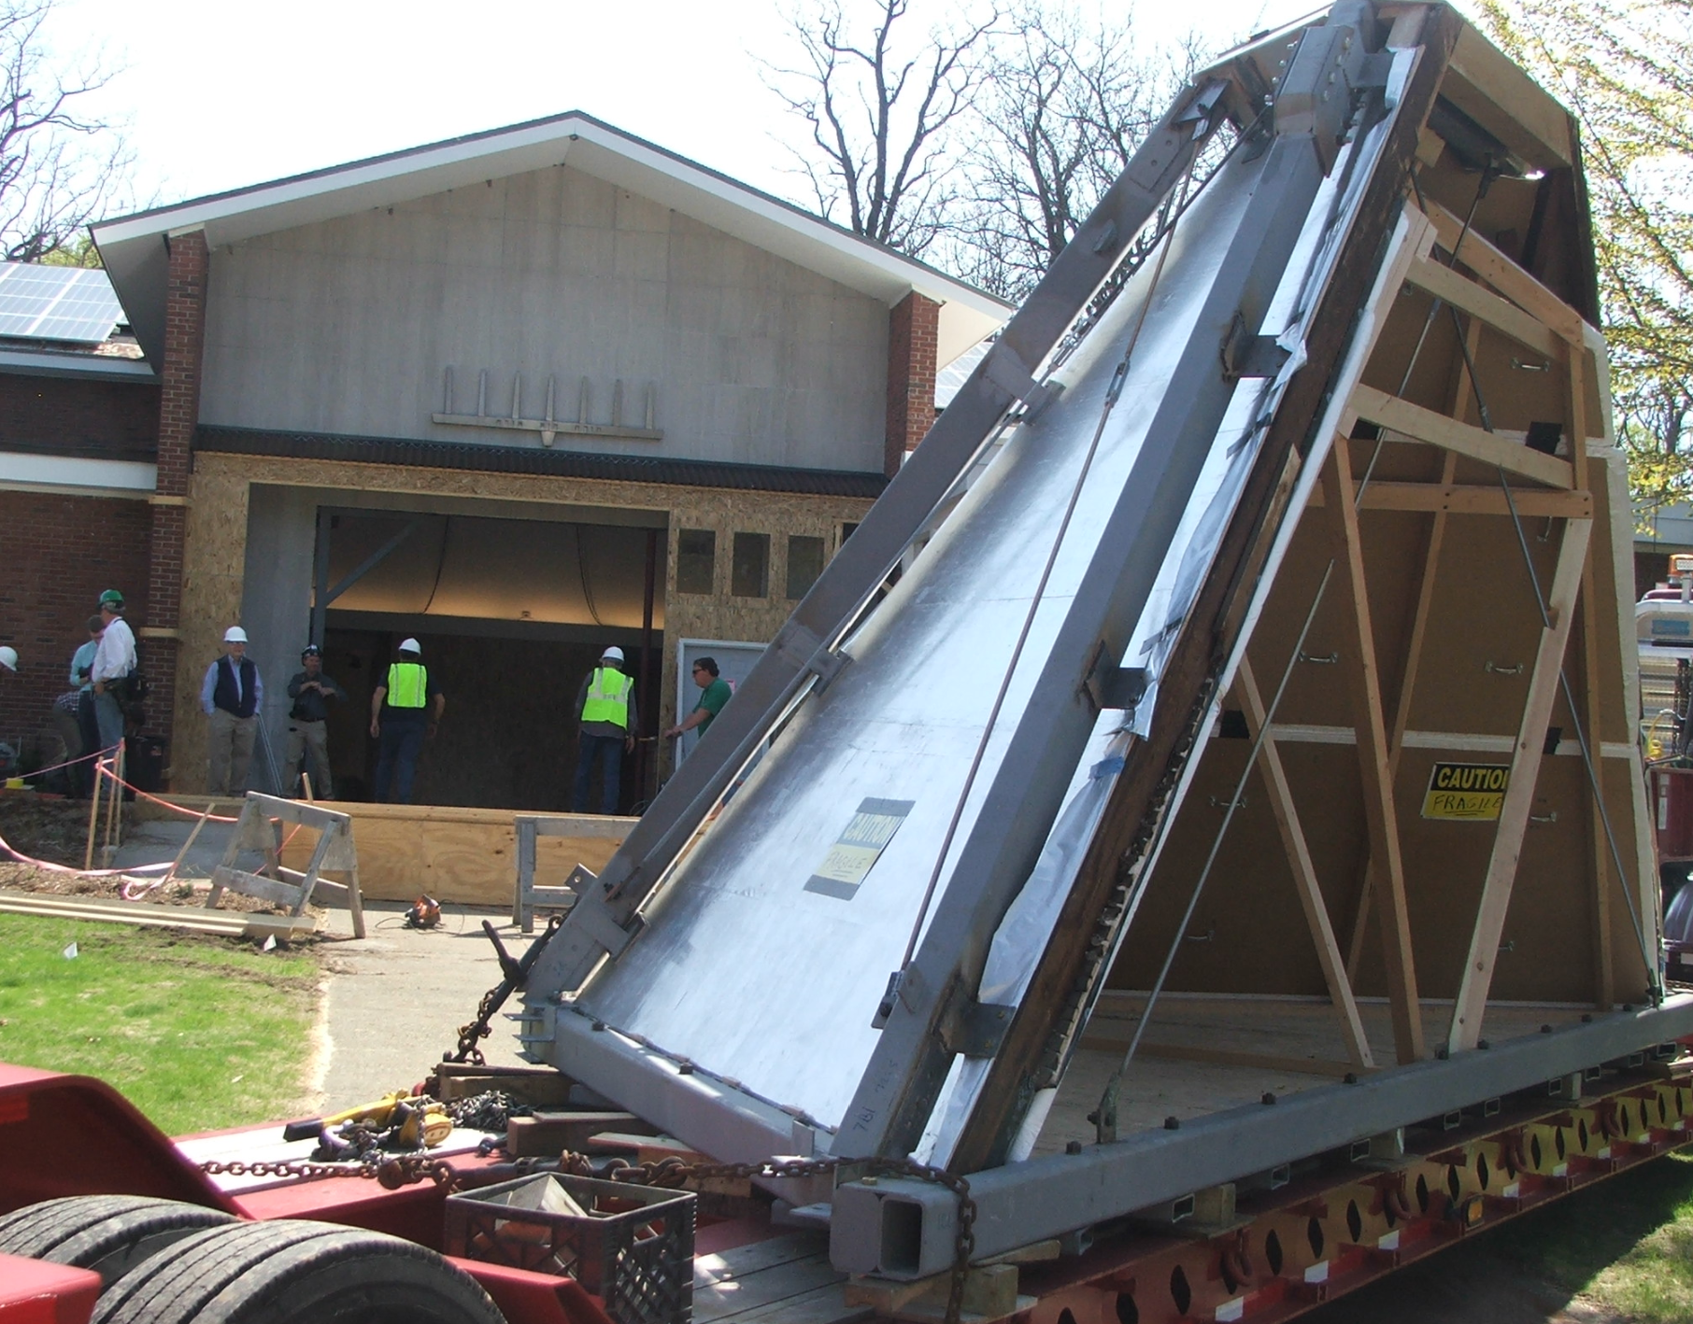

- OZ’s lobby is now home to an amazing artifact, The Lost Mural, that was painted in 1910 in a small synagogue in Burlington. It was painted by Lithuanian immigrant artist Ben Zion Black in vibrant folk-art style that once existed in hundreds of Eastern European synagogues in the 18th and 19th centuries. That Burlington synagogue closed in 1939 and became a carpet warehouse. Then in 1986 it was converted to an apartment building and the mural, still intact, was sealed behind a protective layer of plaster. It was then rescued nearly 25 years later by dedicated volunteers and brought to Ohavi Zedek in 2015. Today it is still undergoing restoration and is recognized as one of only a handful of remaining examples of this art form, described by experts as a “Holocaust Survivor”, and an “accidental survivor of an otherwise vanished past.”

Service Tips

Our siddur (payer book) will be passed out at services and can be found online here. You are invited to follow along. Hebrew and the prayer book page numbering is read from right to left. While much of the Shabbat service is chanted in Hebrew, you can read along with the English translation. Many of our prayers are transliterated so everyone can participate as they wish. Feel free to participate at your own level of comfort. If you prefer, you may simply follow along silently.

Special Thanks!!

- To all our family and friends who have joined us today to celebrate and honor ___ as she becomes a B Mitzvah.
- To Rabbi Amy and Cantor Steve for their teaching and guidance during the past year.
- To Naomi Barell of OZ Hebrew School and all of ___’s teachers.
- Etc.

